To: Local Authority Chief Executives

CC: Other relevant Officers

Circular: CMF2024

16 November 2023

Community Monuments Fund 2024

Dear Chief Executive Officer

I refer to the announcement today by Mr Malcolm Noonan TD, Minister of State for Heritage and Electoral Reform, of the launch of the 2024 Community Monuments Fund.

The 2024 Community Monuments Fund will invest in our valuable archaeological heritage and help the owners and custodians of archaeological monuments to safeguard them into the future for the benefit of communities and the public.

The 2024 Fund will invest a total of €7,000,000 in the conservation, maintenance, protection and promotion of archaeological monuments. It will:

- enable conservation works to be carried out on monuments which are deemed to be significant and in need of urgent support;
- build resilience in our monuments to enable them to withstand the effects of climate change;
- encourage access to monuments and improve their presentation.

The Community Monuments Fund has 3 Streams:

- Stream 1 will offer grants up to €100,000 aimed at essential repairs and capital works for the conservation and repair of archaeological monuments

- Stream 2 will offer grants of up to €30,000 for development of Conservation Management Plans/Reports that are aimed at identifying measures for conservation of archaeological monuments and improving public access.

- Stream 3 will offer grants of up to €30,000 for enhancement of access infrastructure and interpretation (including virtual/) at archaeological monuments.

Full details of the Fund are set out in the Handbook and other documentation attached, which should be carefully read and noted by all applicants.

The Fund should be publicised through all available channels, including your own websites.

Local Authorities and relevant applicants are invited to submit applications and appraisals to cmf@housing.gov.ie by date of deadline. Applications will then be assessed by the Department and Local Authorities will be notified of successful projects as soon as possible thereafter.

Yours sincerely

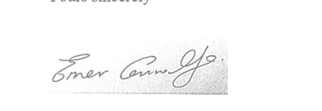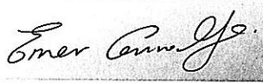
_______________________
Emer Connolly
Principal Officer
National Monuments Service

